Synergistic interaction of phosphate nanoparticles from fish by-products and phosphate-solubilizing bacterial consortium on maize growth and phosphorus cycling
Piera Quattrocelli^{a,*}, Clara Piccirillo^{b}, Eiko E. Kuramae^{c,d}, Robert C. Pullar^{e}, Laura Ercoliª, Elisa Pellegrinoª

ª Institute of Crop Science, Scuola Superiore Sant'Anna, Piazza Martiri della Libertà 33, 56127 Pisa, Italy
^{b} CNR NANOTEC Institute of Nanotechnology, via Monteroni, 73100 Lecce, Italy
^{c} Department of Microbial Ecology, Netherlands Institute of Ecology (NIOO-KNAW), 6708 PB Wageningen, the Netherlands
^{d} Ecology and Biodiversity Group, Department of Biology, Institute of Environmental Biology, Utrecht University, 3584 CH, Utrecht, The Netherlands
^{e} Department of Molecular Science and Nanosystems (DSMN), Università Ca' Foscari Venezia, Venezia Mestre, Venezia (VE) 30172, Italy

* Corresponding author: piera.quattrocelli@santannapisa.it (P. Quattrocelli)

Main contents
Supplementary Materials and Methods
Methods S1. Synthesis and characterization of salmon and tuna nHAs.
Methods S2. In vitro qualitative screening of phosphate solubilization activity by PSB strains.
Methods S3. Additional plant growth-promoting traits and cellulase activity of selected PSB strains.

Supplementary Results
Results S1. Qualitative screening of phosphate solubilization activity by PSB strains.
Results S2. Characterization of OAs secreted by selected PSB strains.

Supplementary Tables
Table S1. Identities and codes of the phosphate-solubilizing bacterial (PSB) strains used for the qualitative in vitro screening with six phosphorus (P) under acidic and alkaline pH.
Table S2. Soil physico-chemical properties of the soil employed in the in vivo experiment.
Table S3. Description of target P genes, primer names, primer forward (F) and reverse (R) sequences, efficiency (%), and reference.
Table S4. Phosphate solubilization index of the screened phosphate-solubilizing bacteria on tricalcium phosphate at pH 5.5 and 7.5.
Table S5. P-values of two-way ANOVAs on the effect on the interaction between phosphate-solubilizing bacteria (PSB) and time point on the solubilization efficiency (%) in tricalcium phosphate, salmon hydroxyapatite nanoparticles and tuna hydroxyapatite nanoparticles under pH 5.5 and 7.5.
Table S6. Permutational analysis of variance, explained variance, and PERMDISP on the effect of phosphate-solubilizing bacteria, substrates, and their interaction on organic acid production under pH 5.5 and 7.5.
Table S7. Permutational analysis of variance pairwise comparisons on the interaction between phosphate-solubilizing bacteria and substrates on organic acid production under pH 5.5 and 7.5.
Table S8. Permutational analysis of variance, explained variance, and PERMDISP on the effect of phosphate-solubilizing bacteria and salmon hydroxyapatite nanoparticle, and their interaction on plant and soil parameters.

Supplementary Figures
Fig. S1. Chemical and morphological characterization of SnHAs and TnHAs.
Fig. S2. Enzymatic index of cellulase activity in selected phosphate-solubilizing bacteria strains, tested for the ability in using carboxymethyl cellulose as substrate.
Fig. S3. Examples of differential P solubilization activity by strain PG0319 (Pseudomonas graminis) under alkaline pH (7.5).
Fig. S4 Solubilized phosphorus (P) in liquid media across four time points by selected phosphate-solubilizing bacteria in tricalcium phosphate, salmon hydroxyapatite nanoparticles and tuna hydroxyapatite nanoparticles under acidic and alkaline pH.
Fig. S5. Linear regressions modelling the relationship between solubilized P (dependent factor) and pH in tricalcium phosphate, salmon hydroxyapatite nanoparticles and tuna hydroxyapatite nanoparticles media over the time under acidic and alkaline conditions.

Supplementary Materials and methods

1. Salmon and tuna nHAs.

After calcination at 700 °C and ball milling, the composition, structure, morphology, and phosphorus (P) concentration of the salmon and tuna hydroxyapatite (SnHAs and TnHAs, respectively) were determined. The phase composition was determined by X-ray diffraction (XRD) using an X’Pert PRO MRD diffractometer (Malvern, Panalytical Ltd., Malvern, UK) with CuKα radiation. Diffraction patterns were acquired with a step size of 0.005° and a count time of 100 seconds, covering an angular range between 20° and 60°. The recorded patterns were compared with the standard Joint Committee on Powder Diffraction File (JCPDF) patterns 01-072-1234 for HA and 09-169 for β-TCP. A semi-quantitative XRD phase analysis was performed using the reference intensity ratio (RIR) method, with corundum as a standard reference (Hubbard and Snyder, 1988). The XRD patterns of SnHAs show a biphasic composition with two intense peaks at 31.0 ° and 31.7 ° which correspond to β-tricalcium phosphate (β-TCP) and hydroxyapatite (HA), respectively (Fig. S1a). The ratio β-TCP:HA in SnHAs was 45%:55 % (w/w), indicating the incomplete conversion of HA to β-TCP during heating. The XRD patterns of tuna hydroxyapatite nanoparticles (TnHAs) showed a unique peak at 31.7 °C (Fig. S1a), characterizing the standard HA XRD pattern (Teixeira et al., 2017). No other phases were detected within the pattern, except for a small shoulder at 31° which corresponds to the β-TCP peak. Since the β-TCP peak was scarcely detected, it is reasonable to assume that the TnHAs were composed of 98-99% pure HA, which is less soluble than β-TCP (Dorozhkin and Epple 2002).
Fourier-transform infrared spectroscopy (FTIR) was conducted using an FT/IR-6000 Jasco spectrometer in transmittance mode (Jasco Europe, Cremella, Italy). Measurements were taken on discs prepared with approximately 2 mg of sample powder mixed with 150 mg of KBr. FTIR spectra were similar between SnHAs and TnHAs (Fig. S1b), with a small peak at 500 cm⁻¹, several peaks at 570-650 cm⁻¹ and a deep broad band around 1100 cm⁻¹ characterizing the phosphate groups (Teixeira et al., 2017). Although the signals at 1088, 1035 and 944 cm⁻¹ correspond to the PO₄ group of HA, in SnHAs an additional peak at 1118 cm⁻¹ (marked with an asterisk on the spectra) was recorded and attributed to β-TCP (Ebrahimi et al., 2017), confirming its presence in SnHAs. The small peak at around 3600 cm⁻¹ and the broad band centered at 3400 cm⁻¹ are typical of hydroxide groups, whereas the weak signal at 1500 cm⁻¹ in both matrices may indicate the presence of carbonate (CO₃²⁻) groups, which improves HA solubility (Pan et al., 2010). A small amount of carbonate is usually present in biogenic HA.
To assess the surface charge of the HA-based powders, zeta potential (ζ) measurements were carried out with a Malvern Nano-ZS90 instrument (Malvern, Panalytical Ltd., Malvern, UK), using a suspension of the powders in distilled water at a concentration of 1 g L⁻¹). All measurements were performed in triplicate. The Zeta potential (ζ) of SnHAs was -34.7 mV (± 0.2 mV) (Fig.S1c), indicating a significant potential difference between the surface of the particles, water and a negative surface charge. ζ larger than -30 mV (or +30 mV) provides a sufficient repulsive force to prevent particle agglomeration and flocculation in suspension, leading to colloidal stability, thus preventing flocculation and aggregation in the absence of stabilizers, additives or surfactants. The ζ of TnHAs was below the threshold of agglomeration (-15.3±0.6 mV) (Fig.S1c), indicating instability in the solution (Mahbubul et al., 2015).
The morphology of the milled powders was analyzed using scanning electron microscopy (SEM) by a Carl Zeiss Merlin instrument equipped with a Gemini II column and an integrated In-lens (Zeiss Sigma 300 VP FE-SEM, Carl Zeiss AG, Oberkochen, Germany). An accelerating voltage of 10 kV was applied. Prior to SEM analysis, samples were sputter-coated with gold to prevent electric charging. The SEM micrographs of SnHAs acquired at 30,000X (Fig. S1d) and 50,000X (Fig. S1e) indicated spherical particles (Ø < 50 nm) which tended to cluster into aggregates. Conversely, SEM micrographs of TnHAs acquired at 50,000X (Fig. S1f) and 80,000X (Fig. S1g) showed elongated particles, ranging from 200 to 400 nm, and a width between 30 and 50 nm. P concentration in SnHAs and TnHAs was determined spectrophotometrically by a Merck Spectroquant kit (Sigma-Aldrich, Milan, Italy), following the method described by Piccirillo et al. (2014).

2. In vitro qualitative screening of phosphate solubilization activity by PSB strains

Fifteen bacterial strains, previously identified as capable of solubilizing β-TCP or classified as potential PSB, were selected from earlier studies (e.g., Pérez-Rodriguez et al., 2020; Sessitsch et al. 2005). The identities, DSMZ numbers, internal codes, and references of these strains are provided in Table S1. The in vitro qualitative screening of the PSB strains was conducted on the National Botanical Research Institute's Phosphate (NBRIP) agar medium (Nautiyal, 1999), supplemented with six different inorganic P sources with varying solubility: β-TCP (5 g L⁻¹), SnHAs (5 g L⁻¹), TnHAs (5 g L⁻¹), mineral nHAs (MnHAs) (5 g L⁻¹; Sigma-Aldrich, Milan, Italy), AlPO₄⁻ (2 g L⁻¹), and FePO₄⁻ (1 g L⁻¹). The pH of the NBRIP medium was adjusted to 5.5 and 7.5 using HCl and KOH, respectively.
The bacterial inoculum was prepared by culturing single colonies in liquid Luria Bertani (LB) medium, followed by incubation at 28 °C in the dark until the exponential phase began (approximately 18-22 hours). The resulting bacterial suspension was adjusted to an optical density at 600 nm (OD600) of 0.1, corresponding to approximately 10⁸ CFU mL⁻¹ based on plate counts. Subsequently, 50 μL of each strain was spotted in triplicate onto NBRIP plates and incubated at 28 °C for 7 days in the dark. Three plates were set up for each bacterial strain, and uninoculated NBRIP plates were used as controls. Phosphate solubilization was assessed by measuring the clear halo surrounding the bacterial colony, indicating the solubilization area. The phosphate solubilization index (PSI) was then calculated using the formula: PSI = [(colony diameter + halo diameter)/colony diameter] (Morales et al., 2011).

3. Additional plant growth-promoting (PGP) traits and cellulase activity of selected PSB strains

The production of IAA by PSB strains was quantified following the method of Cumpa-Velásquez et al. (2021) with slight modifications. In the IAA production assay, the strain Pantoea eucalypti DSM 23077 (PE1109) was included as a positive control since it has proven to be highly productive of IAA (Song et al., 2020). First, each bacterial strain was inoculated into 5 mL of LB supplemented with 0.05% L-tryptophan and incubated overnight at 28 °C in the dark. Later, the inoculum was standardized at an OD600nm of 0.1 using fresh LB supplemented with L-tryptophan and brought to a final volume of 5 mL. Then, the tubes were incubated at 28 °C for 48 h in the dark within a rotary shaker at 140 rpm. Three replicates were set up for each strain. For IAA quantification, an aliquot of 1.5 mL was collected from each sample and centrifuged at 5000 x g for 10 min at room temperature to obtain 500 µL of supernatant. An equal volume of Salkowski’s reagent (FeCl₃ 0.5 M; 35% HClO₄) was mixed with the supernatant, and the resulting suspension was kept in the dark at room temperature for 30 min. Absorbance values at 530 nm were recorded by a spectrophotometer (Infinity Pro200, TECAN) and IAA content (µg mL ⁻¹) was analyzed against a standard curve of commercial IAA (Sigma-Aldrich, Milan, Italy) ranging from 0 to 100 µg mL⁻¹.
Biological N₂-fixation ability was assessed on both solid New Fabio Pedrosa (NFb) (1.5% agar; high O₂ level), and semi-solid NFb (0.15% agar; lower O₂ level), following the method proposed by Batista et al. (2021). For NFb agar, bacterial strains were streaked onto plates and incubated at 28 °C for 7 days. Simultaneously, semi-solid NFb was inoculated by placing a single bacterial colony on the bottom of the glass tubes and incubated at 28 °C at 140 rpm for 7 days. Three replicates were set up for each strain. The PSB strains showing a change in the color medium from green to blue were considered positive for N₂ fixing.
The cellulase activity was measured following the methodology described by Balla et al. (2022). Each strain was spotted in triplicate onto carboxymethylcellulose (CMC) agar plates (average Mw ~90.000; Sigma-Aldrich, Milan, Italy) and incubated at 28 °C. Three plates were set up for each strain. After 72 hours, the plates were flooded with Lugol’s solution to visualize the hydrolysis area around each colony, and the enzymatic index (Ei) was determined (Ferbiyanto et al. 2015).

Supplementary results

1. Qualitative screening of phosphate solubilization activity by PSB strains

At acidic pH, strains CC1, CC2, CT1006, BM0204, PK0810 and PM12647 reached a phosphate solubilization index (PSI) equal to 1.0 and produced a slight halo zone on the plate, whereas strains PE1109, PF0520 and PP0220 showed a PSI ranging between 1.1 and 1.4, and strains PC1218, PG0319, PP0616, PG1211, PR0393 and PT0405 achieved a PSI > 1.5 (Table S4). Under alkaline conditions, the PSB strains exhibited higher solubilization activity than under acidic pH. In fact, only three strains (BM0204, PK0810 and PM12647) showed a weak solubilization (PSI = 1.0), while six strains (CC1, CC2, CT1006, PP0220, PE1109 and PF0520) reached PSI values 1.1 to 1.4, and six of them (PG0319, PG1211, PR0393, PC1218, PT0405 and PP0616) showed a PSI ≥ 1.5. Therefore, based on the highest PSI, the six best-performing strains (i.e., PG0319, PG1211, PR0393, PC1211, PT0405 and PP0616) and a mild P solubilizer (PF0520) were selected for the quantitative screening of P solubilization (Table 1; Table S1).

Table S1. Identities and codes of the phosphate-solubilizing bacterial (PSB) strains used for the qualitative in vitro screening with six phosphorus (P) substrates (tricalcium phosphate, TCP; mineral hydroxyapatite nanoparticles, MnHAs; salmon hydroxyapatite nanoparticles, SnHAs; tuna hydroxyapatite nanoparticles, TnHAs; aluminium phosphate, AlPO4-; iron phosphate, FePO4-) under acidic and alkaline pH (5.5 and 7.5). References are also reported.
PSB strain identity | DSMZ number * | Internal code † | Reference
Cellulosimicrobium cellulans | DSM 20106 | CC1 | Pérez-Rodriguez et al., 2020
Cellulosimicrobium cellulans | DSM 46031 | CC2 | Pérez-Rodriguez et al., 2020
Cellulosimicrobium terreum | DSM 18665 | CT1006 | Pérez-Rodriguez et al., 2020
Pantoea eucalypti | DSM 23077 | PE1109 | Cumpa-Velasquez et al., 2021
Paraburkholderia terricola | DSM 17221 | PT0405 | Sessitsch et al. 2005; Onofre-Lemus et al. 2009; Gasser et al., 2011
Paraburkholderia phytofirmans | DSM 17436 | PP0616 | Sessitsch et al. 2005; Naveed et al., 2014
Paraburkholderia phytofirmans | DSM 103130 | PP0220 | Sessitsch et al. 2005; Naveed et al., 2014
Priestia megaterium | DSM 3228 | BM0204 | Liu et al., 2015
Pseudomonas corrugata | DSM 7228 | PC1218 | Pérez-Rodriguez et al., 2020
Pseudomonas fluorescens | DSM 289 | PF0520 | Park et al., 2009
Pseudomonas graminis | DSM 100941 | PG0319 | Pereira et al., 2016
Pseudomonas graminis | DSM 11363 | PG1211 | Pereira et al., 2016
Pseudomonas koreensis | DSM 16610 | PK0810 | Lopes et al., 2018
Pseudomonas moorei | DSM 12647 | PM12647 | Pereira et al., 2016
Pseudomonas rhodesiae | DSM 7527 | PR0393 | Azziz et al., 2021
*DSMZ: German Collection of Microorganisms and Cell Cultures GnbH (https://www.dsmz.de).
†Internal code: the code used in the study.

Table S2. Soil physico-chemical properties of the soil employed in the in vivo experiment.
Properties
pH [1:2.5 H₂O] | 8.1
Kjeldahl-N (g kg⁻¹) | 1.4
Olsen-P (mg kg⁻¹) | 45
SOM (%) | 2.1
C/N | 9
C.S.C (meq 100g⁻¹) | 10.8
Clay (%) | 13.5
Silt (%) | 32.4
Sand (%) | 54.1

Table S3. Description of target P genes, primer names, primer forward (F) and reverse (R) sequences, efficiency (%), and reference.
Target gene | Primer names | Primer sequences (5'→ 3') | Efficiency (%) | Reference
PHT1;1 | PhT1_F | F- GCAGAACCAGGACAGGAGCA | 109 | designed in this study
phosphate transporter 1;1 | PhT1_R | R- GTGCAGTGCAGGAAGGAACAC | 109 | designed in this study
PHT1;2 | PhT2_F | F- GACGACCACTTCAACTCCAC | 109 | designed in this study
phosphate transporter 1;2 | PhT2_R | R- GCATCTTCATCCGCCAGTAG | 109 | designed in this study
PHT1;4 | PhT4_F | F- CGAGTACGCCAACAAGAGG | 107 | designed in this study
phosphate transporter 1;4 | PhT4_R | R- TGGAGGTGAAGTGGTCGTC | 107 | designed in this study
PHT1;5 | PhT5_F | F- CGACCATATAAATTTGGTGCC | 107 | Alzate Zuluaga et al., 2021
phosphate transporter 1;5 | PhT5_R | R- CACATATCACGAAGTAGTGCC | 107 | Alzate Zuluaga et al., 2021
PHT1;6 | PhT6_F | F- ACATAAACGCCCTCAAGGAG | 96 | Tian et al., 2013
phosphate transporter 1;6 | PhT6_R | R- GACGGTGACCCAGTAGCC | 96 | Tian et al., 2013
ACP1  acid phosphatase 1 | ACP1_F | F- GCCCTCATCTGCTACTCACT | 109 | designed in this study
ACP1  acid phosphatase 1 | ACP1_R | R- CTCTCGACAAACTCAGCACG | 109 | designed in this study
poliub7  polyubiquitin containing 7 ubiquitin monomers | Poliub_F | F- GCTGCTGTATCTGGGTTATC | 106 | Pii et al., 2016
poliub7  polyubiquitin containing 7 ubiquitin monomers | Poliub_R | R- CGCACGATAGTTTTGGGTAA | 106 | Pii et al., 2016

Table S4. Phosphate solubilization index (PSI) of the screened phosphate-solubilizing bacteria (PSB) on tricalcium phosphate (TCP) at pH 5.5 and pH 7.5.
 | PSI *
Strain * | pH 5.5 | pH 7.5
CC1 | 1.0 ± 0.0 a † | 1.2 ± 0.1 ab
CC2 | 1.0 ± 0.0 a | 1.2 ± 0.0 ab
CT1006 | 1.0 ± 0.0 a | 1.2 ± 0.0 ab
PE1109 | 1.1 ± 0.0 ab | 1.3 ± 0.0 abc
PT0405 | 2.1 ± 0.0 e | 2.2 ± 0.0 e
PP0616 | 1.5 ± 0.3 bcd | 1.6 ± 0.3 bcd
PP0220 | 1.3 ± 0.1 a-d | 1.2 ± 0.0 abc
BM0204 | 1.0 ± 0.0 a | 1.0 ± 0.0 a
PC1218 | 1.5 ± 0.1 bcd | 1.6 ± 0.1 bcd
PF0520 | 1.2 ± 0.0 abc | 1.4 ± 0.0 abc
PG0319 | 1.5 ± 0.0 bcd | 1.7 ± 0.0 cd
PG1211 | 1.6 ± 0.0 cd | 1.9 ± 0.0 de
PK0810 | 1.0 ± 0.0 a | 1.0 ± 0.0 a
PM12647 | 1.0 ± 0.0 a | 1.0 ± 0.0 a
PR0393 | 1.6 ± 0.0 d | 1.8 ± 0.1 de
*PSB strain was used as factor. See Table S1 for strain identities.
†Data are mean (n=3) ± SE. Different letters represent significant differences among PSB strains according to one-way ANOVA and post hoc Tukey-B test (P ≤ 0.05).

Table S5. P-values of two-way ANOVAs on the effect on the interaction between phosphate-solubilizing bacteria (PSB) and time point on the solubilization efficiency (%) in tricalcium phosphate (TCP), salmon hydroxyapatite nanoparticles (SnHAs), and tuna hydroxyapatite nanoparticles (TnHAs) under acidic and alkaline pH (5.5 and 7.5, respectively). PSB strain and time point were used as fixed factors. Four replicates for each substrate and pH condition.
 | TCP |  |  |  | SnHAs |  |  |  | TnHAs
 | pH 5.5 |  | pH 7.5 |  | pH 5.5 |  | pH 7.5 |  | pH 5.5 |  | pH 7.5
PSB strain * | <0.001 † |  | <0.001 ‡ |  | <0.001 ‡ |  | <0.001 ‡ |  | <0.001 ‡ |  | <0.001 ‡
Time ‡ | <0.001 ‡ |  | <0.001 ‡ |  | <0.001 ‡ |  | <0.001 ‡ |  | <0.001 ‡ |  | <0.001 ‡
PSB strain x time ‡ | <0.001 ‡ |  | <0.001 ‡ |  | <0.001 ‡ |  | <0.001 ‡ |  | <0.001 ‡ |  | <0.001 ‡
*Seven selected PSB strains (n=4). See Table S1 for PSB identities.
†In bold statistically significant P values (P ≤ 0.05).
‡Four time points: zero, three, five and seven days after inoculation (T0, T3, T5, and T7).

Table S6. Permutational analysis of variance (PERMANOVA), explained variance, and PERMDISP of the effects of phosphate-solubilizing bacteria (PSB) and substrates on the organic acid production in acidic and alkaline pH. OAs were analyzed at the end of the in vitro quantitative screening of P solubilization activity (T7). Data were normalized and the Euclidean distance matrix between samples was calculated.
 | df | pseudo-F | P(MC) * | Explained variance  (%) | PERMDISP † |  | df | pseudo-F | P(MC) | Explained variance  (%) | PERMDISP
 | pH 5.5 |  |  |  |  |  | pH 7.5
Strain † | 7 | 92.49 | 0.001 | 26.3 | 0.001 |  | 7 | 71.59 | 0.001 | 24.2 | 0.001
Substrate † | 2 | 30.28 | 0.001 | 24.6 | 0.849 |  | 2 | 15.27 | 0.001 | 14.8 | 0.015
Strain x Substrate | 14 | 51.75 | 0.001 | 29.5 |  |  | 14 | 56.00 | 0.001 | 37.9
*In bold statistically significant values (P < 0.05).
†PERMDISP based on 999 permutations.
‡Strains: PG0319, PG1211, PC1218, PR0393, PF0520, PT0405; Table S1) and control (CTRL). Substrate: β-tricalcium phosphate (β-TCP); salmon hydroxyapatite nanoparticles (SnHAs), tuna hydroxyapatite nanoparticles (TnHAs).

Table S7. Results of permutational multivariate analysis of variance (PERMANOVA) pairwise comparisons on the effects of the interaction between phosphate-solubilizing bacteria (PSB) and substrates on the organic acid production under acidic (pH 5.5), and alkaline pH (pH 7.5).
Pairs (Strain x Substrate) * | P(MC)
 | pH 5.5 |  | pH 7.5
PG0319
β-TCP vs SnHAs | 0.011 † |  | 0.039
β-TCP vs TnHAs | 0.010 |  | 0.073
SnHAs vs TnHAs | 0.003 |  | 0.002
PG1211
β-TCP vs SnHAs | 0.022 |  | 0.046
β-TCP vs TnHAs | 0.021 |  | 0.132
SnHAs vs TnHAs | 0.005 |  | 0.002
PC1218
β-TCP vs SnHAs | 0.021 |  | 0.017
β-TCP vs TnHAs | 0.057 |  | 0.016
SnHAs vs TnHAs | 0.009 |  | 0.013
PR0393
β-TCP vs SnHAs | 0.077 |  | 0.021
β-TCP vs TnHAs | 0.088 |  | 0.008
SnHAs vs TnHAs | 0.003 |  | 0.024
PF0520
β-TCP vs SnHAs | 0.004 |  | 0.003
β-TCP vs SnHAs | 0.002 |  | 0.003
β-TCP vs TnHAs | 0.013 |  | 0.002
PT0405
β-TCP vs SnHAs | 0.087 |  | 0.150
β-TCP vs TnHAs | 0.048 |  | 0.004
SnHAs vs TnHAs | 0.089 |  | 0.299
CTRL
β-TCP vs SnHAs | 0.002 |  | 0.016
β-TCP vs TnHAs | 0.003 |  | 0.131
SnHAs vs TnHAs | 0.005 |  | 0.072
*Strains: PG0319, PG1211, PC1218, PR0393, PF0520, PT0405; Table S1) and control (CTRL). Substrate: β-tricalcium phosphate (β-TCP); salmon hydroxyapatite nanoparticles (SnHAs), tuna hydroxyapatite nanoparticles (TnHAs).
†In bold statistically significant values (P < 0.05).

Table S8. Permutational analysis of variance (PERMANOVA), explained variance, and PERMDISP on the effect of the application of phosphate-solubilizing bacteria (PSB) (no bacteria, NB; seed coating, SC; seed coating + PSB reinforcement, BR), salmon hydroxyapatite nanoparticles (SnHAs) (no SnHAs, -S; SnHAs, +S), and their interaction on plant and soil parameters. Data were normalized and the Euclidean distance matrix between samples was calculated. Three replicates for each treatment.
 | df | pseudo-F | P(MC) | Explained variance  (%) | PERMDISP *
PSB † | 2 | 8.11 | 0.001 ‡ | 38.6 | 0.56
SnHAs | 1 | 5.47 | 0.379 | 11.4 | 0.30
PSB x SnHAs | 5 | 0.99 | 0.001 | 50.0 | 0.66
*PERMDISP based on 999 permutations.
†PERMANOVA was performed using PSB and SnHAs as fixed factors.
‡In bold statistically significant P values (P ≤ 0.05).

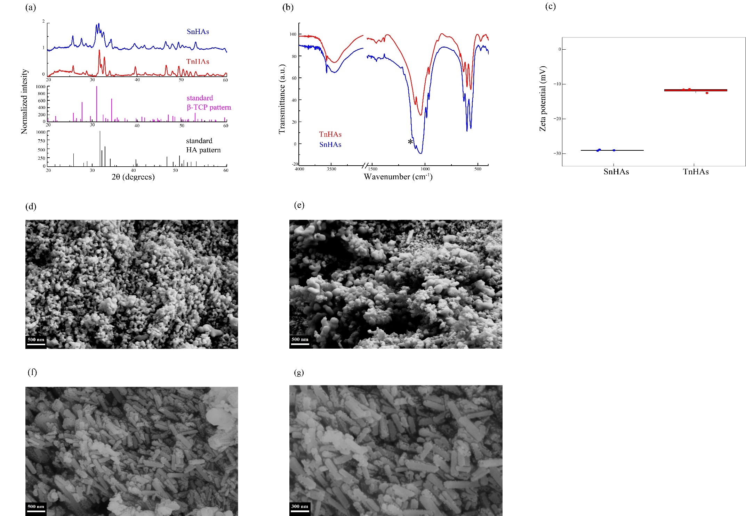
Fig. S1. (a) XRD patterns of SnHAs (blue) and TnHAs (red) compared to β-TCP (pink) and HA (black) standards; (b) FTIR spectra of SnHAs (blue) and TnHAs (red); (c) ζ potential of SnHAs (blue) and TnHAs (red); SEM micrographs of SnHAs acquired at (d) 30.000X and at (e) 50.000X magnification; SEM micrographs of TnHAs acquired at (f) 50.000X and at (g) 80.000X magnification.

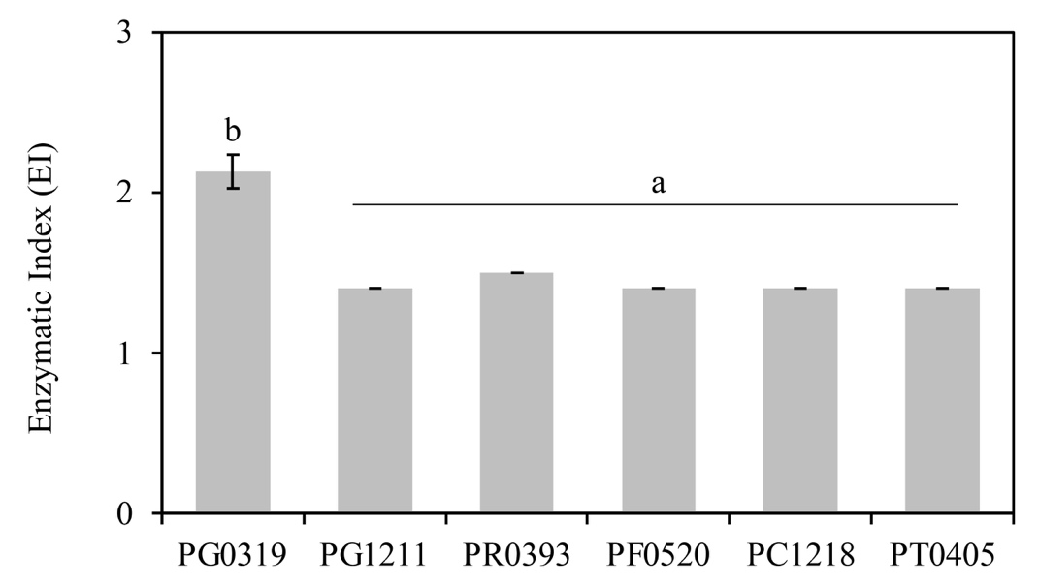
Fig. S2. Enzymatic index (EI) of cellulase activity in selected phosphate-solubilizing bacteria (PSB) strains, tested for the ability in using carboxymethyl cellulose (CMC) as substrate. Data are mean ± SE. Three replicates for each PSB strain. Strains were considered positive to cellulase production with an Ei of 1, meaning that they were able to grow on plates amended with CMC. Different letters represent significant differences among strains, according to one-way ANOVA and post hoc Tukey-B test (P ≤ 0.05)
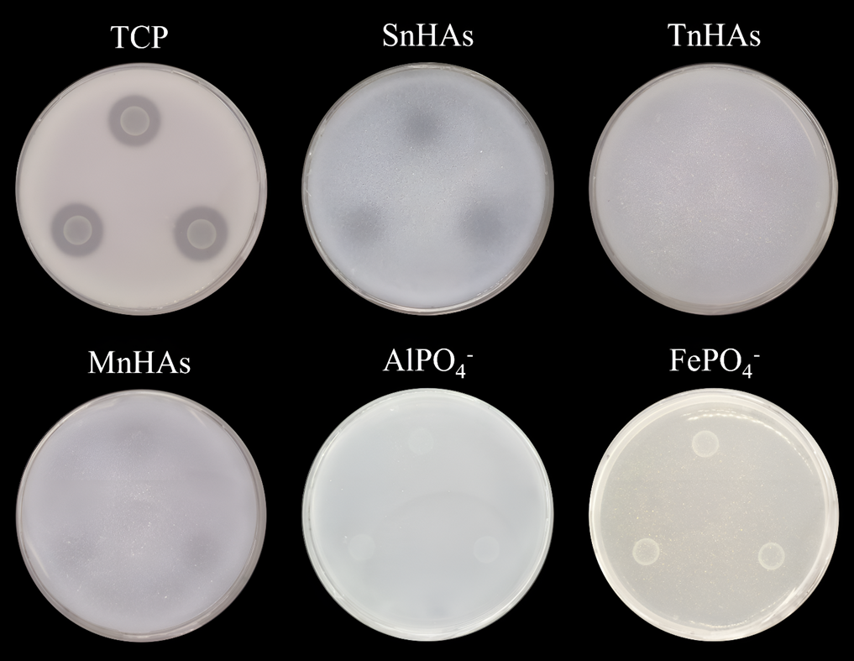
Fig. S3. Examples of differential P solubilization activity by strain PG0319 (Pseudomonas graminis) on petri plates amended with all the tested substrates (i.e., tricalcium phosphate, TCP; salmon hydroxyapatite nanoparticles, SnHAs; tuna hydroxyapatite nanoparticles, TnHAs; mineral hydroxyapatite nanoparticles, MnHAs; aluminum phosphate, AlPO₄⁻; iron phosphate, FePO₄⁻) under alkaline pH (7.5).

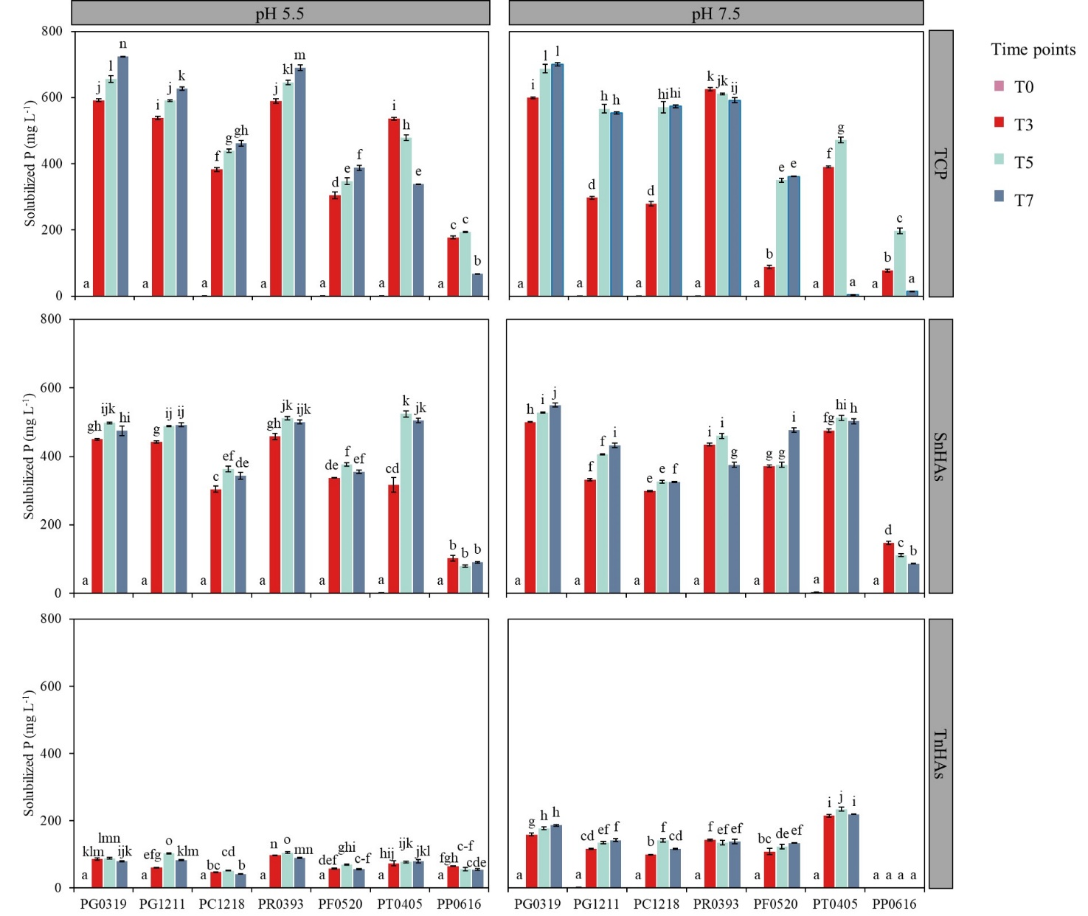
Fig. S4. Solubilized phosphorus (P) (mg L⁻¹) in liquid media across four time points (T0, T3, T5, and T7) by selected phosphate-solubilizing bacteria (PSB) in tricalcium phosphate (TCP), salmon hydroxyapatite nanoparticles (SnHAs) and tuna hydroxyapatite nanoparticles (TnHAs) under acidic and alkaline pH (5.5 and 7.5, respectively). See Table S1 for PSB identities. Data are mean ± SE (n=4). Different letters represent significant differences among PSB strains and time points, according to two-way ANOVA and post hoc Tukey-B test (PSB strain x time: P < 0.001).

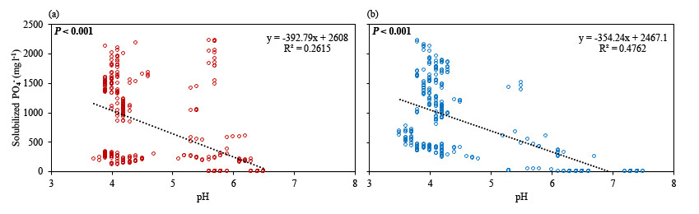
Fig. S5. Linear regressions modelling the relationship between solubilized P (dependent factor) and pH (independent factor) in tricalcium phosphate (TCP), salmon hydroxyapatite nanoparticles (SnHAs) and tuna hydroxyapatite nanoparticles (TnHAs) media over the time (four time points; T0, T3, T5, T7) under acidic (a) and alkaline (b) conditions. The regression equations, R² and statistical significances are reported.
References

Alzate Zuluaga, M.Y., Martinez de Oliveira, A.L., Valentinuzzi, F., Tiziani, R., Pii, Y., Mimmo, T., Cesco, S., 2021. Can inoculation with the bacterial biostimulant Enterobacter sp. strain 15S be an approach for the smarter P fertilization of maize and cucumber plants? Front. Plant Sci.,12, 719873.
Azziz, G., Bajsa, N., Haghjou, T., Taulé, C., Valverde, Á., Igual, J.M., Arias, A., 2012. Abundance, diversity, and prospecting of culturable phosphate solubilizing bacteria on soils under crop pasture rotations in a no tillage regime in Uruguay. Appl. Soil Ecol. 61, 320 326.
Balla, A., Silini, A., Cherif-Silini, H., Bouket, A.C., Boudechicha, A., Luptakova, L., Alenezi, F.N., Belbahri, L., 2022. Screening of cellulolytic bacteria from various ecosystems and their cellulases production under multi-stress conditions. Catalysts 12, 769.
Batista, B.D., Bonatelli, M.L., Quecine, M.C., 2021. Fast screening of bacteria for plant growth promoting traits, in: The Plant Microbiome: Methods and Protocols, Springer, Beerlin, Germany, pp. 61-75.
Cumpa-Velásquez, L.M., Moriconi, J.I., Dip, D.P., Castagno, L.N., Puig, M.L., Maiale, S.J., Santa-María, G.E., Sannazzaro, A.I., Estrella, M.J., 2021. Prospecting phosphate solubilizing bacteria in alkaline-sodic environments reveals intra-specific variability in Pantoea eucalypti affecting nutrient acquisition and rhizobial nodulation in Lotus tenuis. Appl. Soil Ecol. 168, 104125.
Dorozhkin, S.V., Epple, M., 2002. Biological and medical significance of calcium phosphates. Angewandte Chemie Internat. Edit. 41, 3130-3146.
Ebrahimi, M., Botelho, M.G., Dorozhkin, S.V., 2017. Biphasic calcium phosphates biocer amics (HA/TCP): Concept, physicochemical properties, and the impact of standardization of study protocols in biomaterials research. Mat. Sci Eng. 71, 1293-1312.
Ferbiyanto, A., Rusmana, I., Raffiudin, R., 2015. Characterization and identification of cellulolyticbacteria from gut of worker Macrotermes gilvus. Hayati J. Biosci. 22, 197-200.
Gasser, I., Cardinale, M., Müller, H., Heller, S., Eberl, L., Lindenkamp, N., Kaddor, C., Steinbüchel, A., Berg, G., 2011. Analysis of the endophytic lifestyle and plant growth promotion of Burkholderia terricola ZR2-12. Plant Soil, 347, 125-136.
Liu, Z., Li, Y.C., Zhang, S., Fu, Y., Fan, X., Patel, J.S., Zhang, M., 2015. Characterization of phosphate-solubilizing bacteria isolated from calcareous soils. Appl. Soil Ecol. 96, 217 224.
Lopes, L. D., Pereira e Silva, M.D.C., Weisberg, A.J., Davis, E.W., Yan, Q., Varize, C.D.S., Wu, C.F., Chang, J.H., Loper, J.E., Andreote, F.D., 2018. Genome variations between rhizosphere and bulk soil ecotypes of a Pseudomonas koreensis population. Environ. Microbiol. 20, 4401-4414.
Mahbubul, I.M., Elcioglu, E.B., Amalina, M.A., Saidur, R.J.P.T., 2019. Stability, thermophysical properties and performance assessment of alumina–water nanofluid with emphasis on ultrasonication and storage period. Powder Technol., 345, 668-675.
Morales, A., Alvear, M., Valenzuela, E., Castillo, C.E., Borie, F., 2011. Screening, evaluation and selection of phosphate-solubilising fungi as potential biofertilizer. J. Plant Nutr. Soil Sci. 11, 89-103.
Naveed, M., Hussain, M.B., Zahir, Z.A., Mitter, B., Sessitsch, A., 2014. Drought stress amelioration in wheat through inoculation with Burkholderia phytofirmans strain PsJN. Plant Growth Regul. 73, 121-131.
Nautiyal, C.S., 1999. An efficient microbiological growth medium for screening phosphate solubilizing microorganisms. FEMS Microbiol. Lett. 170, 265-270.
Onofre-Lemus, J., Hernández-Lucas, I., Girard, L., Caballero-Mellado, J., 2009. ACC (1 aminocyclopropane-1- carboxylate) deaminase activity, a widespread trait in Burkholderia species, and its growth-promoting effect on tomato plants. Appl. Environ. Microbiol. 75, 6581-6590.
Pan, H., Darvell, B.W., 2010. Effect of carbonate on hydroxyapatite solubility. Cryst. Growth Des. 10, 845-850.
Park, K.H., Lee, C.Y., Son, H.J., 2009. Mechanism of insoluble phosphate solubilization by Pseudomonas fluorescens RAF15 isolated from ginseng rhizosphere and its plant growth promoting activities. Lett. Appl. Microbiol. 49, 222-228.
Pereira, S.I.A., Monteiro, C., Vega, A.L., Castro, P.M., 2016. Endophytic culturable bacteria colonizing Lavandula dentata L. plants: isolation, characterization and evaluation of their plant
growth-promoting activities. Ecol. Eng. 87, 91-97.
Pérez-Rodriguez, M.M., Piccoli, P., Anzuay, M.S., Baraldi, R., Neri, L., Taurian, T., Lobato Ureche, M.A., Segura, D.M., Cohen, A.C., 2020. Native bacteria isolated from roots and rhizosphere of Solanum lycopersicum L. increase tomato seedling growth under a reduced fertilization regime. Sci. Rep.-UK, 10, 15642.
Piccirillo, C., Pullar, R.C., Tobaldi, D.M., Castro, P.L., Pintado, M.E., 2014. Hydroxyapatite and chloroapatite derived from sardine by-products. Ceram. Int. 40, 13231-13240.
Pii, Y., Alessandrini, M., Dall’Osto, L., Guardini, K., Prinsi, B., Espen, L., Zamboni, A., Varanini, Z., 2016. Time-resolved investigation of molecular components involved in the induction of NO₃– high affinity transport system in maize roots. Front. Plant Sci. 7, 1657.
Sessitsch, A., Coenye, T., Sturz, A.V., Vandamme, P., Barka, E.A., Salles, J.F., Van Elsas, J.D., Faure, D., Reiter, B., Glick, B.R., Wang-Pruski, G., Nowak, J., 2005. Burkholderia phytofirmans sp. nov., a novel plant-associated bacterium with plant-beneficial properties. Intern. J. Syst. Evol. Micr. 55, 1187-1192.
Song, Z., Lu, Y., Liu, X., Wei, C., Oladipo, A., Fan, B., 2020. Evaluation of Pantoea eucalypti FBS135 for pine (Pinus massoniana) growth promotion and its genome analysis. J. Appl. Microbiol. 129, 958-970.
Teixeira, M.A.C., Piccirillo, C., Tobaldi, D.M., Pullar, R.C., Labrincha, J.A., Ferreira, M.O., Castro, P.M.L., Pintado, M.M.E., 2017. Effect of preparation and processing conditions on UV-absorbing properties of hydroxyapatite-Fe₂O₃ sunscreen. Mater. Sci. Eng., 141-149.
Tian, H., Drijber, R.A., Li, X., Miller, D.N., Wienhold, B.J., 2013. Arbuscular mycorrhizal fungi differ in their ability to regulate the expression of phosphate transporters in maize (Zea mays L.). Mycorrhiza 23, 507-514.

